**Business Questions**

1. Which districts are the most prone to crime and at what time of day?

The results from the queries and the visualizations show that the most crime-prone neighborhood are Roxbury, Dorchester, and South End.

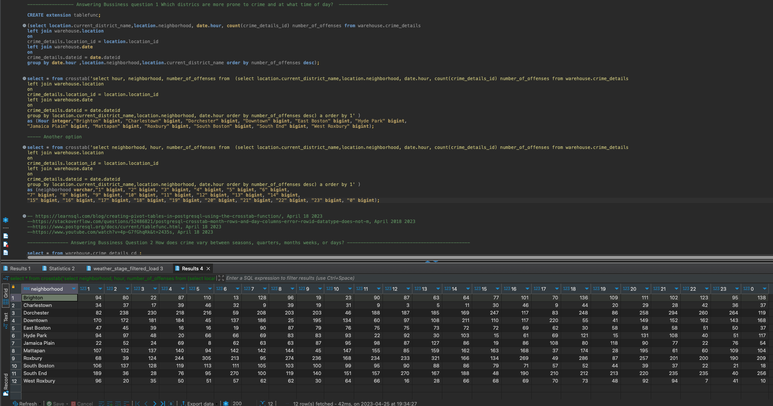

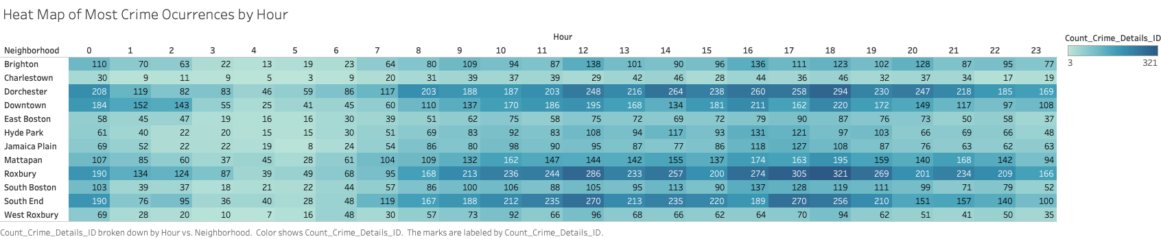

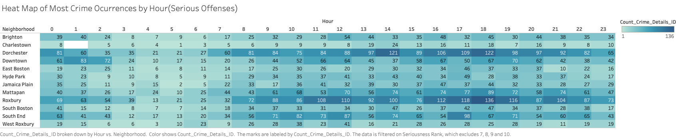

1. How does crime vary between seasons, quarters, months weeks, or days?

Is there a relationship between weather and crime? Are hot days more likely?

Are hot days more likely to cause violent crime to rise?

This is a long question. After exploring a few relationships and performing some visualization analysis, it can be concluded that:

1. In General, the second half of the month is slightly mor prone to crime.

1. Summer is the season with highest number of crimes reported. This also aligns with Quarter 3.

1. Last months of summer show greater crime activity.

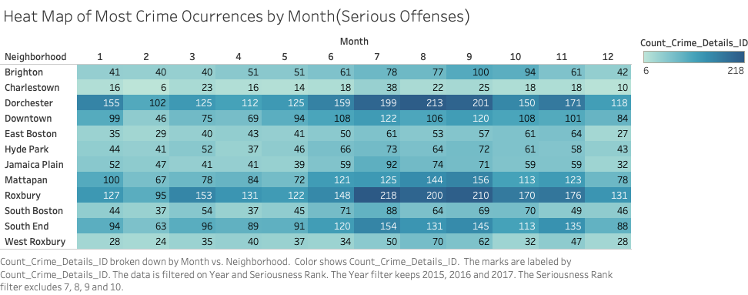

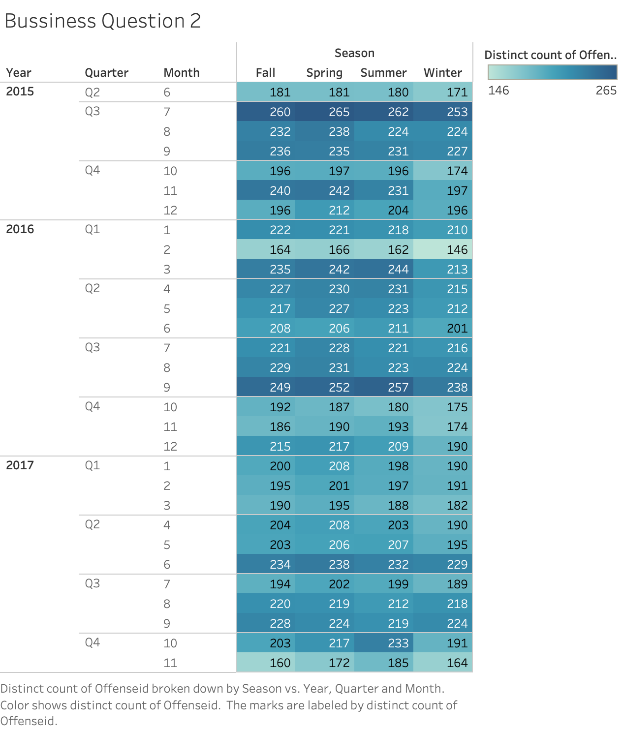

1. Fridays seem to have a spike of crime activity.

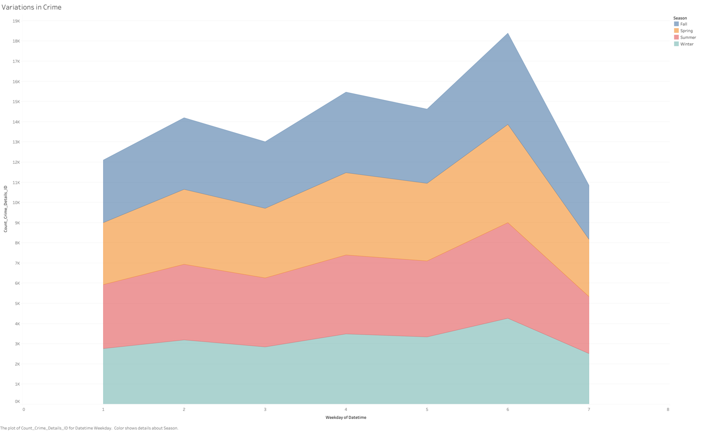

1. Is there a relationship between weather and crime? Are hot days more likely?
   1. Are hot days more likely to cause violent crime to rise?

Mild temperatures seem to be associated with higher crime.

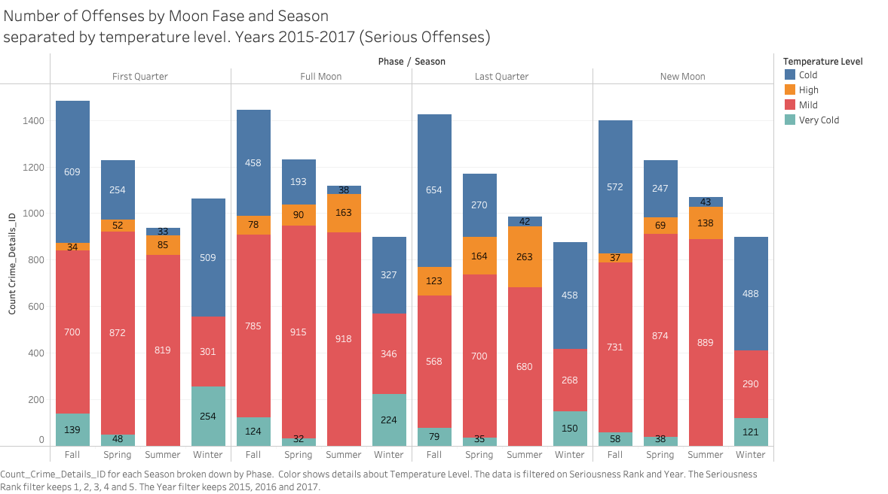

* 1. Are hidden weather features that may also be related to crime?

High humidity and high atmospheric pressure is strongly associated with crime occurrence.

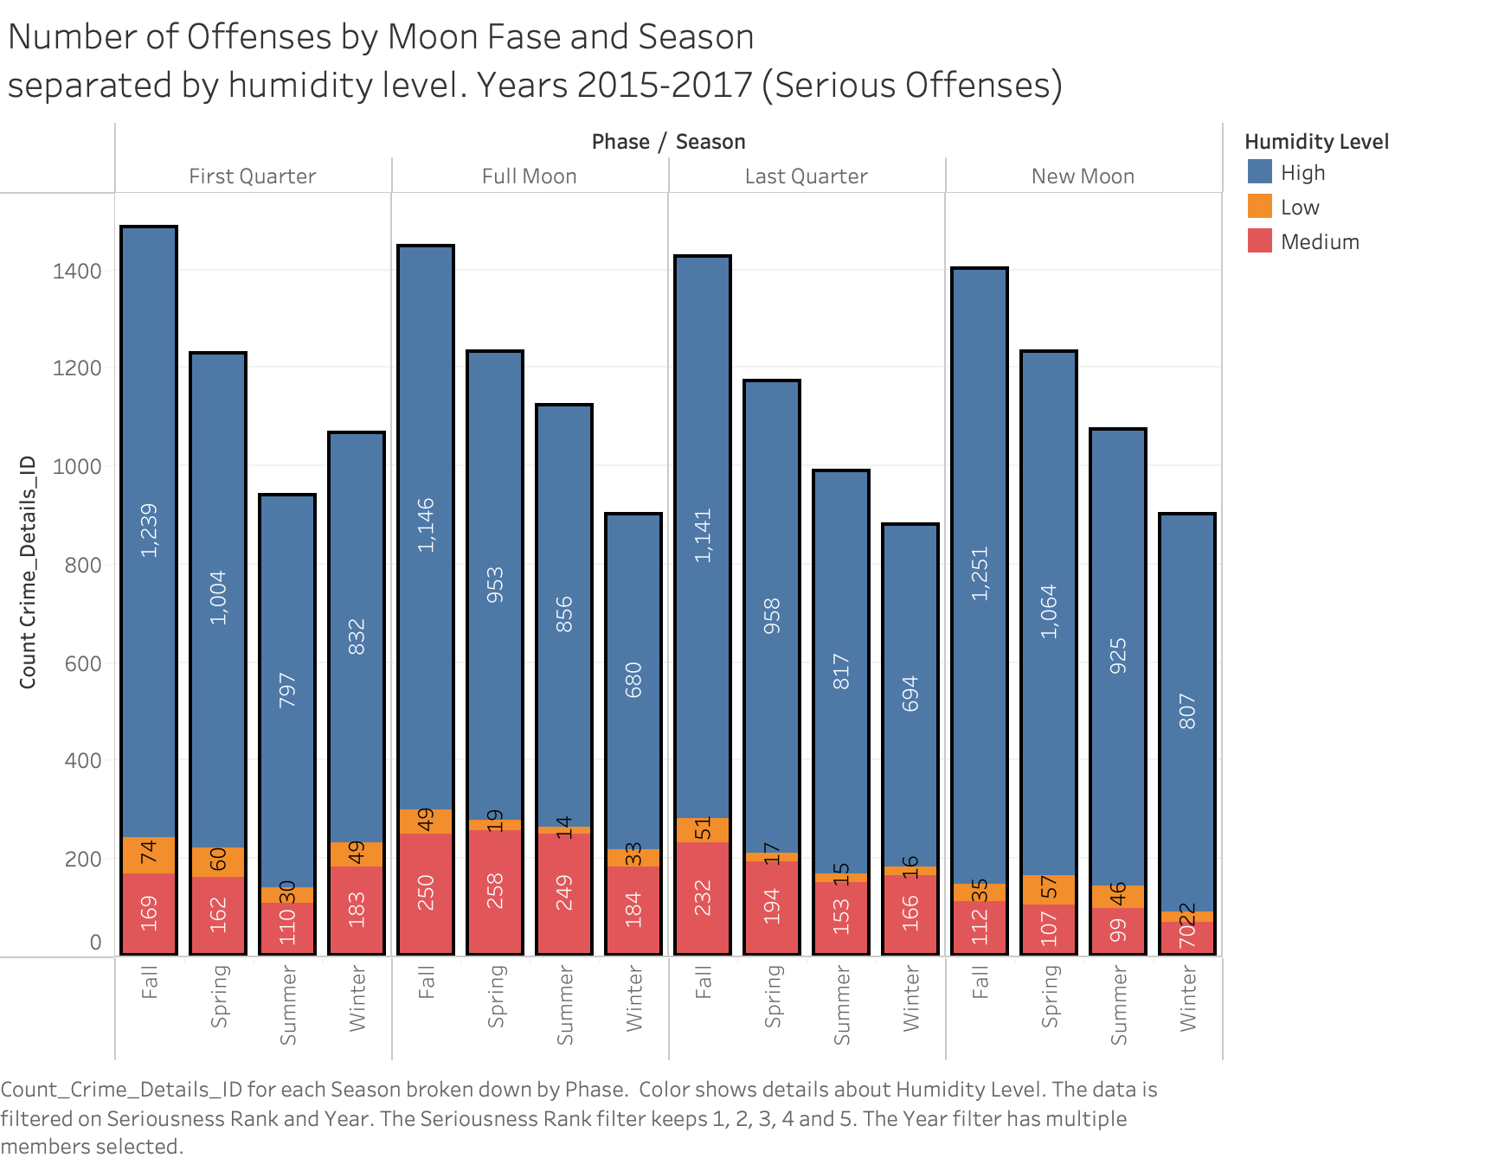

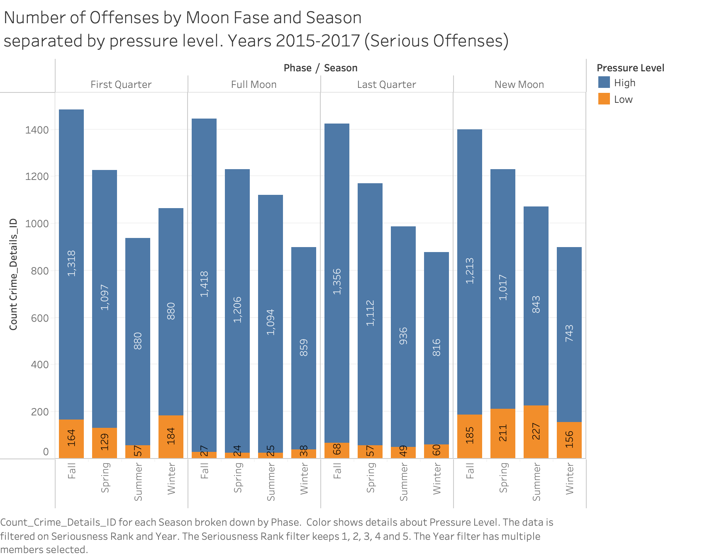

1. What is the trend of certain crimes, is it increasing, decreasing, or remaining?

There is no visible trend between crime occurrence and time (For years 2015-2017).

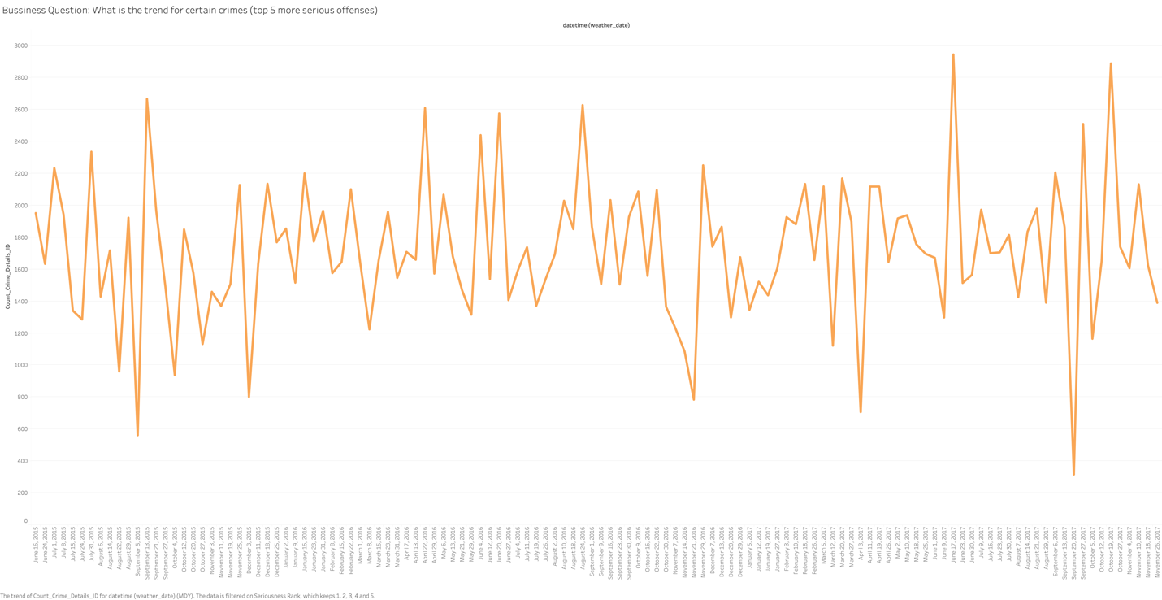

1. Are there any other hidden patterns that may be influencing crime in the city?

For example, lunar cycle.

No evident relationship between Moon Cycle and occurrence of crime can be appreciated for the years of 2015 and 2017 for all Boston neighborhoods.

